ATACseq Analysis  
Kfir Inbal, Bioinformatician, Madi Lab

Step 1 – QC, Alignment & Peak Calling (Shell Environment)

The original ".bam" files were first converted into FASTQ format for quality analysis using FastQC [1]. The FASTQ files underwent quality refinement with Trimmomatic [2] and Repair.sh from BBMap [3]. The repair script was used to ensure that paired-end reads are correctly matched, removing any mismatches and generating fixed FASTQ files for subsequent analysis. Alignment to the Hg38 reference genome was performed using BWA-MEM [4]. Post-alignment, no duplicates were detected. Mitochondrial chromosomes and blacklist regions were removed to reduce noise and bias, and read coordinates were shifted to account for Tn5 transposase insertion using alignment sieve [5]. Peak calling was performed with MACS2 [6], and footprinting analysis was conducted using TOBIAS [7].

Step 2 – Metadata

A metadata file, Sample_Sheet_All.csv, was created to categorize the samples into four groups: CD4_Good, CD4_Poor, CD8_Good, and CD8_Poor, based on the general metadata from the experiment (2024-04-26 Sample info ATAC.xlsx). This categorization was necessary for the subsequent differential analysis and comparisons in R.

Step 3 – Data Preparation and Differential Analysis (R Studio; DiffBind)

Sample metadata sheets for each experiment (Sample_Sheet_CD4.csv and Sample_Sheet_CD8.csv) were created from the aligned and filtered BAM files and MACS2 peak files. These sheets served as inputs for the dba function to compare the Good and Poor groups within each experiment. The analysis included the execution of dba.blacklist, dba.count, and dba.normalize functions, employing TMM normalization. Differential analysis was carried out using dba.contrast to compare Good and Poor groups for both CD4 and CD8 datasets, followed by dba.analyze using the EdgeR method to identify differentially bound sites (DBS).

Sample correlations were visualized using a heatmap generated by dba.plotHeatmap. Principal component analysis (PCA) was performed with dba.plotPCA, using the parameters DBA_CONDITION and label=DBA_ID. Differential Binding Sites (DBS) were analyzed with dba.report, focusing on p-values due to the limited number of sites with FDR < 0.01. A threshold of 0.05 was applied for significant DBS, while a threshold of 1 was used for all DBS, regardless of significance. Gene names corresponding to the start and end positions of each DBS were included.

Volcano plots were created from the comprehensive DBS dataset, defining significant genes as those with p-values < 0.05 and logFC > -log(0.7) or < log(0.7). Genes with -log10(p-value) > 5 were capped at y = 5 on the plot. The top ten most significant genes were annotated on the volcano plot. It is important to note that each dot on the volcano plots represents a differentially bounded site within a gene, meaning the same gene name may appear multiple times.

Pathway enrichment analysis was conducted using the fgsea [10] package in R. The gene list comprised all genes identified as DBS. The C7 immunologic signature gene sets from MSigDB (c7.all.v2023.2.Hs.symbols.gmt) were used as the pathway database, with parameters set to minSize = 15, maxSize = 1000, and eps = 0. Results were categorized into CD4 and CD8-related pathways, with non-relevant pathways manually excluded. Each pathway subset was sorted by normalized enrichment score (NES), and the top 30 pathways were classified as up-regulated or down-regulated based on NES sign. A point plot was generated to display the top 30 pathways, with point size representing the number of genes within each pathway.

Results

CD4 Experiment – Good vs Poor

Correlation Matrix Plot & PCA Plot:

**B**

**A**

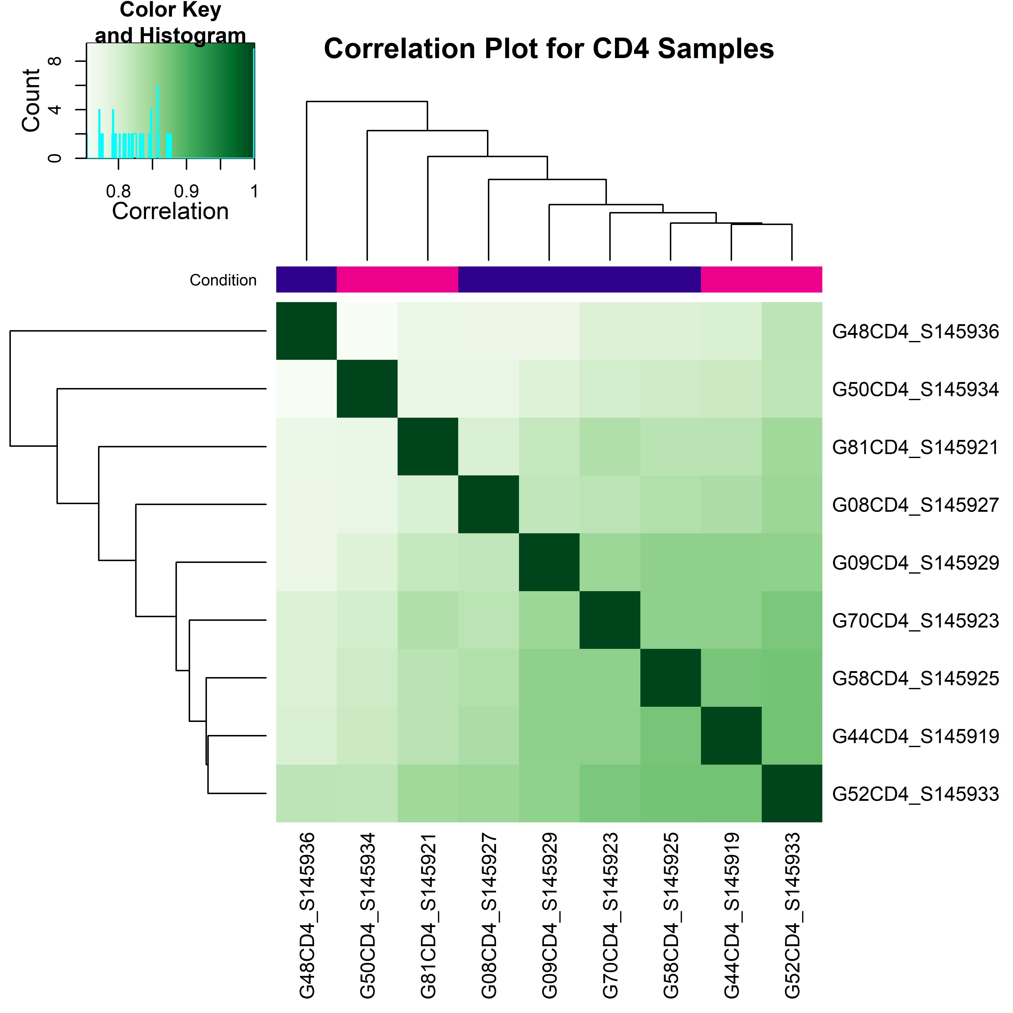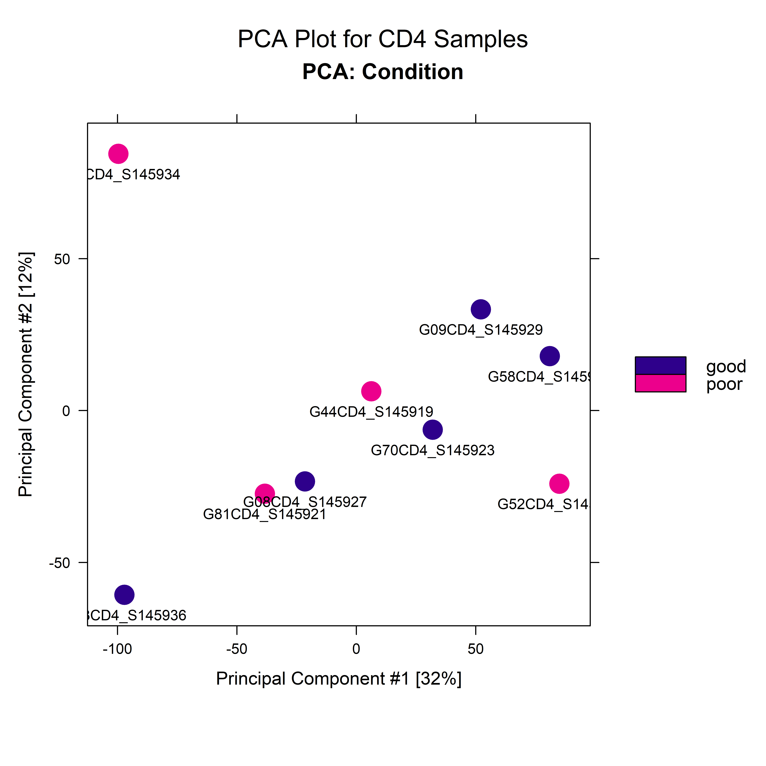

Volcano Plot:

**C**

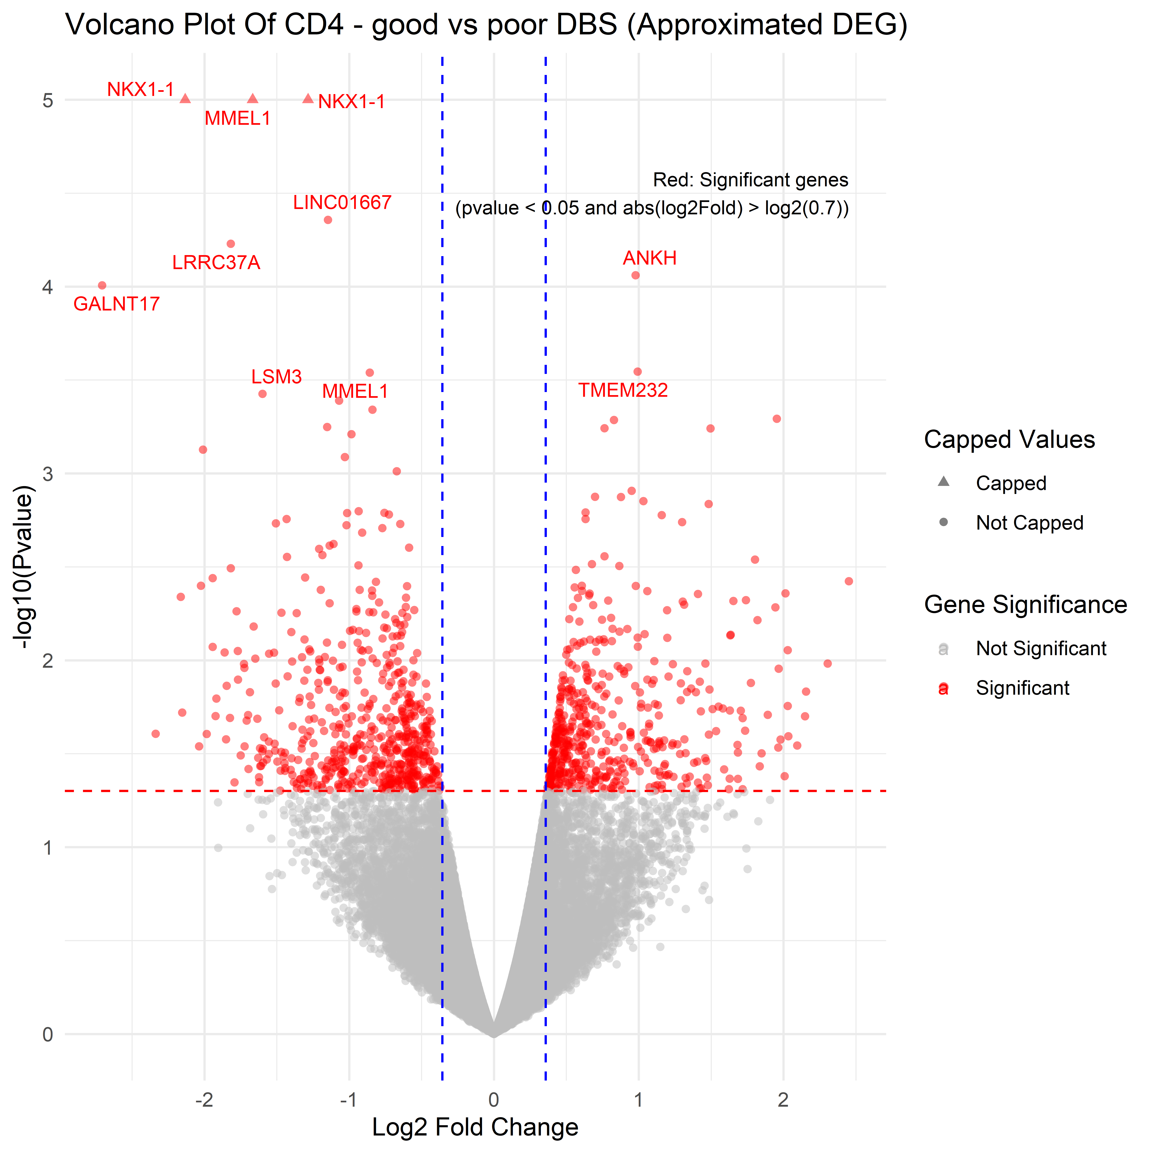

***Up_In_CD4_Good***

***Up_In_CD4_Poor***

GSEA plots:

CD4 related pathways:

**D**



Figure Legend:

A – Correlation heatmap of CD4 samples, illustrating the hierarchical clustering of samples based on their correlation coefficients. These coefficients measure the similarity between the binding patterns across different samples, based on their binding affinity scores obtained from differential analysis. The color key represents the correlation values, with darker shades indicating higher correlation. Conditions are color-coded in the annotation bar above the heatmap.

B – PCA plot of CD4 samples, showing separation based on the condition (good vs. poor). Samples are color-coded by condition, with good in blue and poor in pink.

C – Volcano plot displaying differential binding sites between good and poor CD4 samples. Significant genes p-value < 0.05 and |log2FoldChange| > log2(0.7) are highlighted in red. The x-axis represents log2 fold change, while the y-axis represents -log10(p-value). Capped and uncapped values are distinguished by triangles and circles, respectively. Key upregulated genes are labeled.

D – Top 30 enriched CD4-related pathways from the CD4 experiment. Each dot represents a pathway, with dot size corresponding to the number of genes involved in that pathway. The normalized enrichment score (NES) indicates the degree of upregulation.

CD8 Experiment – Good vs Poor

Correlation Matrix Plot & PCA Plot:

**B**

**A**

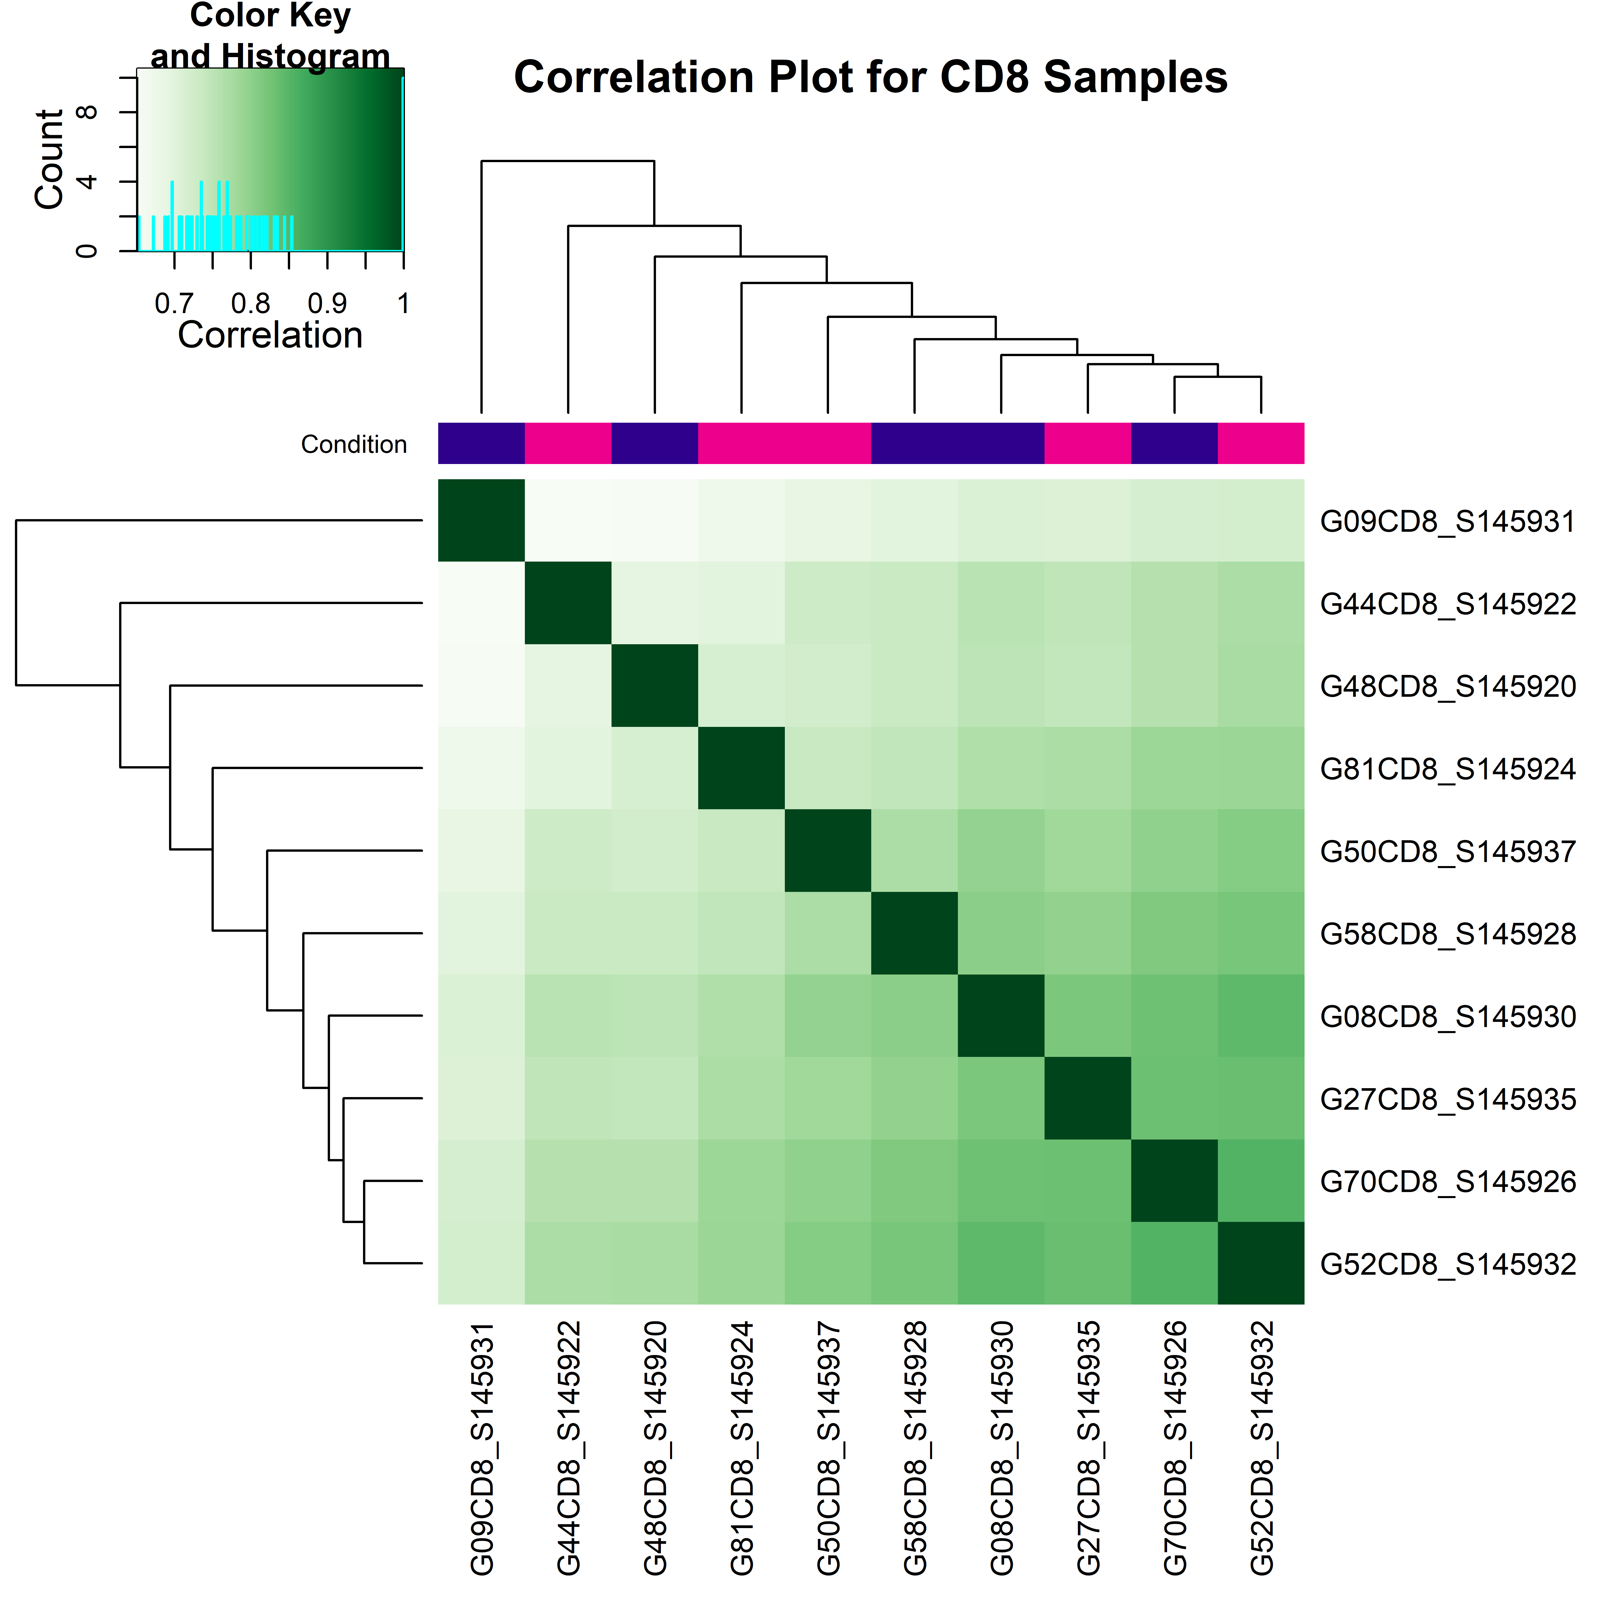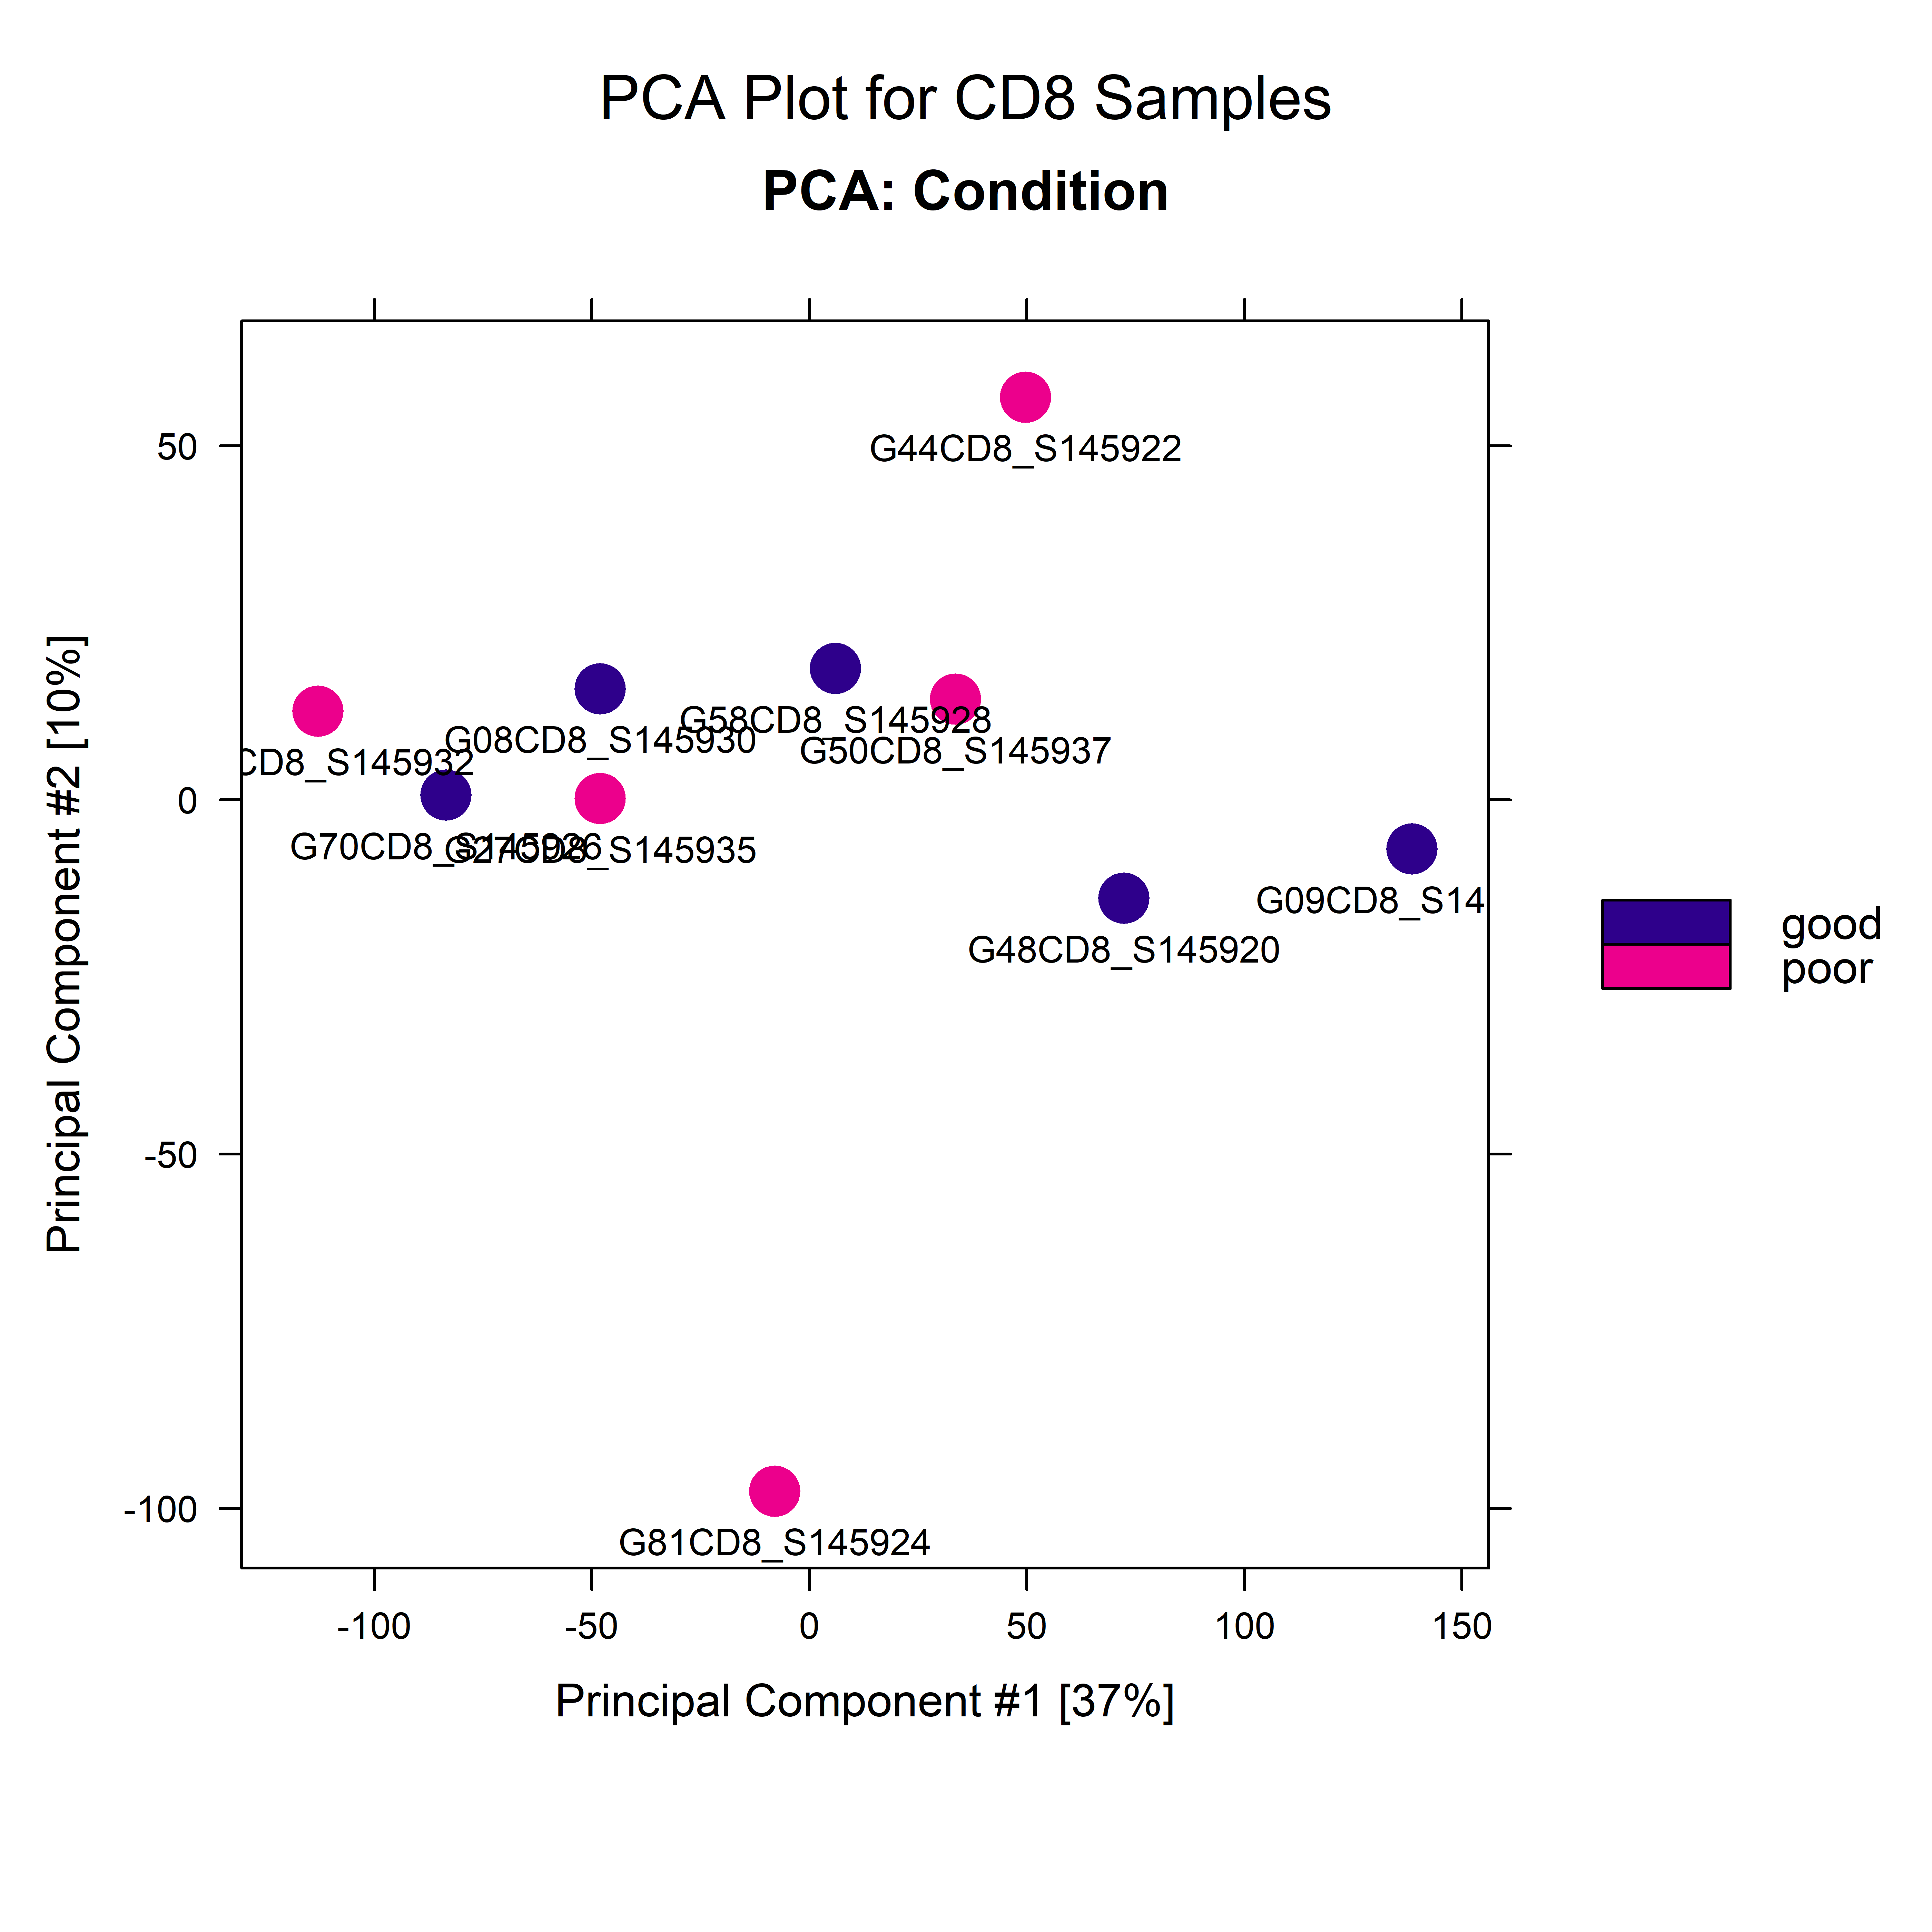

Volcano plot:

**C**

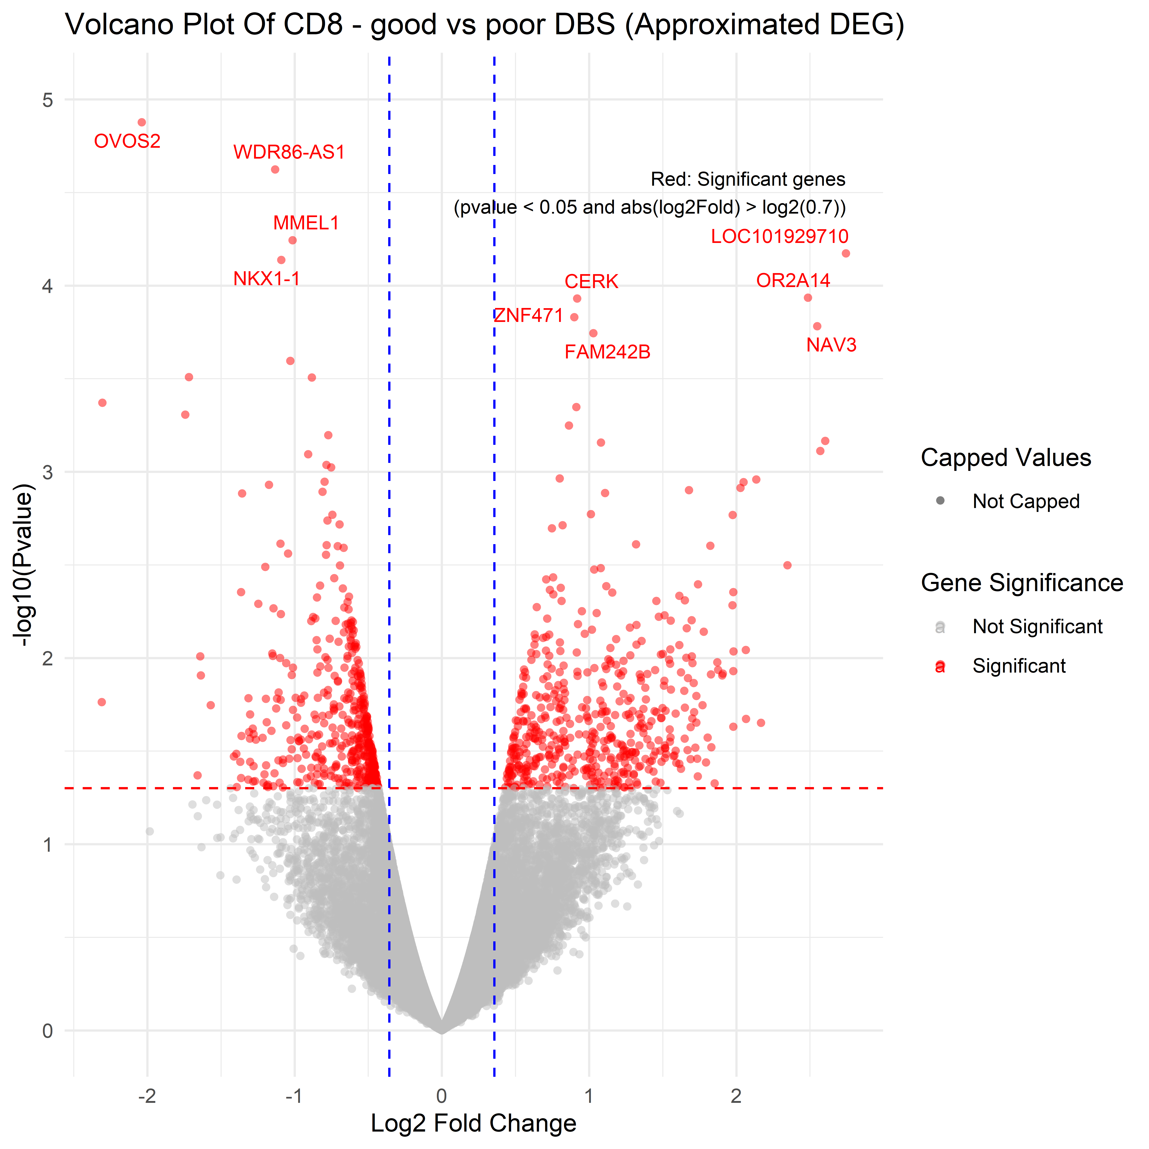

***Up_In_CD8_Good***

***Up_In_CD8_Poor***

GSEA plots:

CD8 related pathways:

**D**



Figure Legend:

A – Correlation heatmap of CD8 samples, illustrating the hierarchical clustering of samples based on their correlation coefficients. These coefficients measure the similarity between the binding patterns across different samples, based on their binding affinity scores obtained from differential analysis. The color key represents the correlation values, with darker shades indicating higher correlation. Conditions are color-coded in the annotation bar above the heatmap.

B – PCA plot of CD84 samples, showing separation based on the condition (good vs. poor). Samples are color-coded by condition, with good in blue and poor in pink.

C – Volcano plot displaying differential binding sites between good and poor CD8 samples. Significant genes p-value < 0.05 and |log2FoldChange| > log2(0.7) are highlighted in red. The x-axis represents log2 fold change, while the y-axis represents -log10(p-value). Capped and uncapped values are distinguished by triangles and circles, respectively. Key upregulated genes are labeled.

D – Top 30 enriched CD8-related pathways from the CD8 experiment. Each dot represents a pathway, with dot size corresponding to the number of genes involved in that pathway. The normalized enrichment score (NES) indicates the degree of upregulation.

Summary So Far

Until now, we have conducted open chromatin analysis at the gene level using DiffBind in R, examining differential accessibility between poor and good responders in both CD4 and CD8 cells. Next, using TOBIAS, we will explore differential transcription factor binding sites across these groups, aiming to identify TFs with altered binding patterns in CD4 and CD8 cells.

Step 4 – Bulk Categorization for TOBIAS (Shell Environment)

The aligned and filtered ".bam" files were merged using Samtools [11] because TOBIAS analysis requires a single aggregated BAM file for each experimental group. Since TOBIAS cannot process multiple individual BAM files together for group comparisons, merging ensures that each group (e.g., CD4_Good, CD4_Poor, CD8_Good, CD8_Poor) is represented by one combined BAM file. This aggregation is essential for accurate analysis and comparison, as it consolidates data from multiple samples into a single file per group.

Step 5 – TOBIAS Analysis (Shell Environment)

As mentioned, the aligned and filtered BAM files were organized into groups: CD4 (Good and Poor) and CD8 (Good and Poor). The BAM files for each group were merged into single files to facilitate bulk comparison between Good and Poor categories. TOBIAS functions were then applied: ATACorrect to generate single basepair cutsite tracks, ScoreBigWig to compute continuous footprinting scores across regions, and BINDetect to assess differential binding of transcription factors between the groups. For the BINDetect comparison, peak files from the Good and Poor groups were combined to consolidate the peak data into a single dataset. Additionally, the JASPAR 2024 core non-redundant database of transcription factors [8] was used. Following the BINDetect analysis, a volcano plot was generated to visualize the results, with significant genes defined as those with p-values < 0.05 and logFC > -log(0.9) or < log(0.9).

To strengthen the comparison, we intersected the differentially expressed (DE) transcription factors (TFs) identified from TOBIAS BINDetect results with those from the R DiffBind [9] analysis. TFs that were commonly found in both analyses with the same fold-change direction were filtered based on a threshold of -log(0.9) in the fold change from either DiffBind or TOBIAS BINDetect results. Selected TFs, including POU1F1 (Up_Good), GLIS1 (Up_Poor), POU4F3 (Up_Good), and VEZF1 (Up_Poor), were chosen for the footprinting "aggregate" plot across all sites. This type of plot visualizes the aggregate footprinting signal across a set of genomic regions, such as transcription factor binding sites, providing a summary view of the footprinting data across multiple samples or conditions. Same TFs were also visualized as a heatmap using TOBIAS PlotHeatmap function.

Results

CD4 Good vs Poor

Differentially Bound Motifs Volcano Plot

**A**



Aggregated Footprinting Plots And Heatmaps

Aggregate Plots

**B**

**CD4 Up_Good:**

POU1F1 –

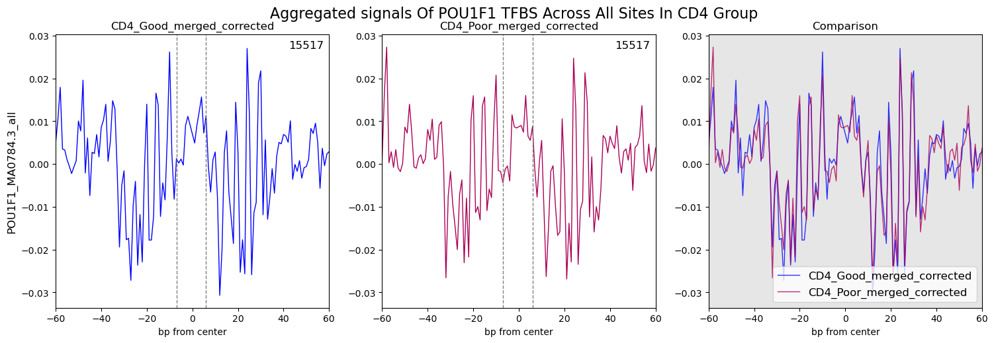

POU4F3 –

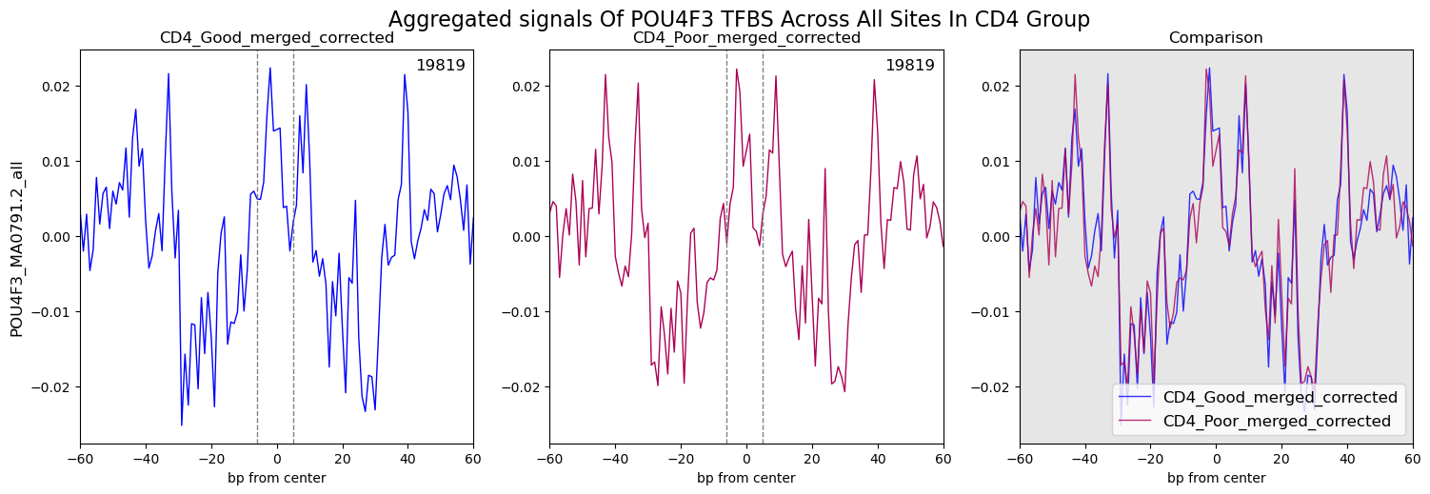

**CD4 Up_Poor:**

GLIS1 –

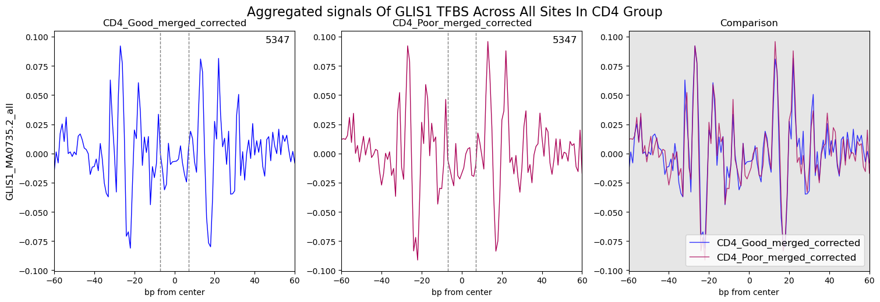

VEZF1 –

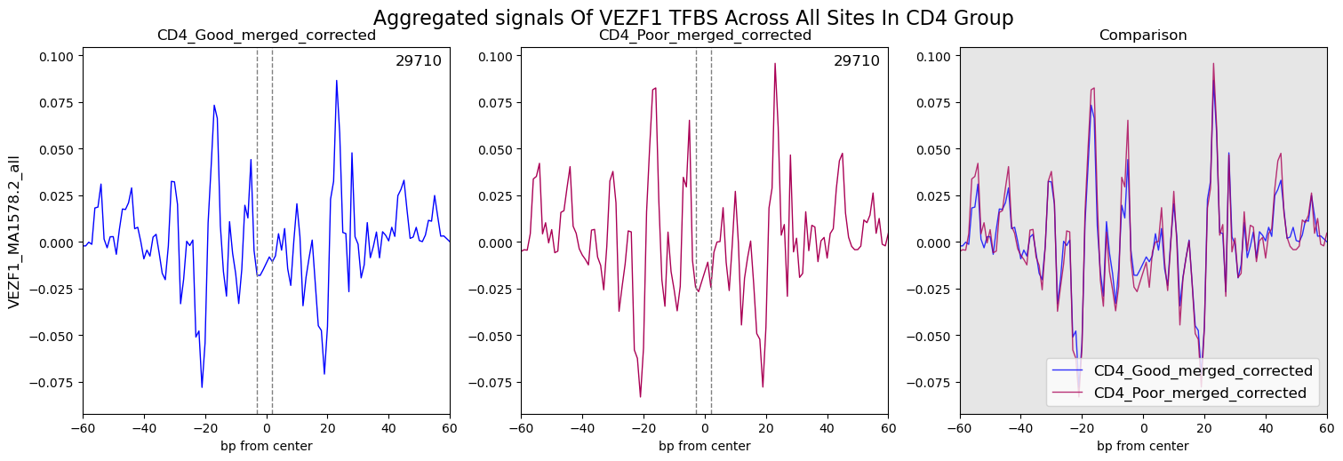

**CD4 Heatmaps**

**C**

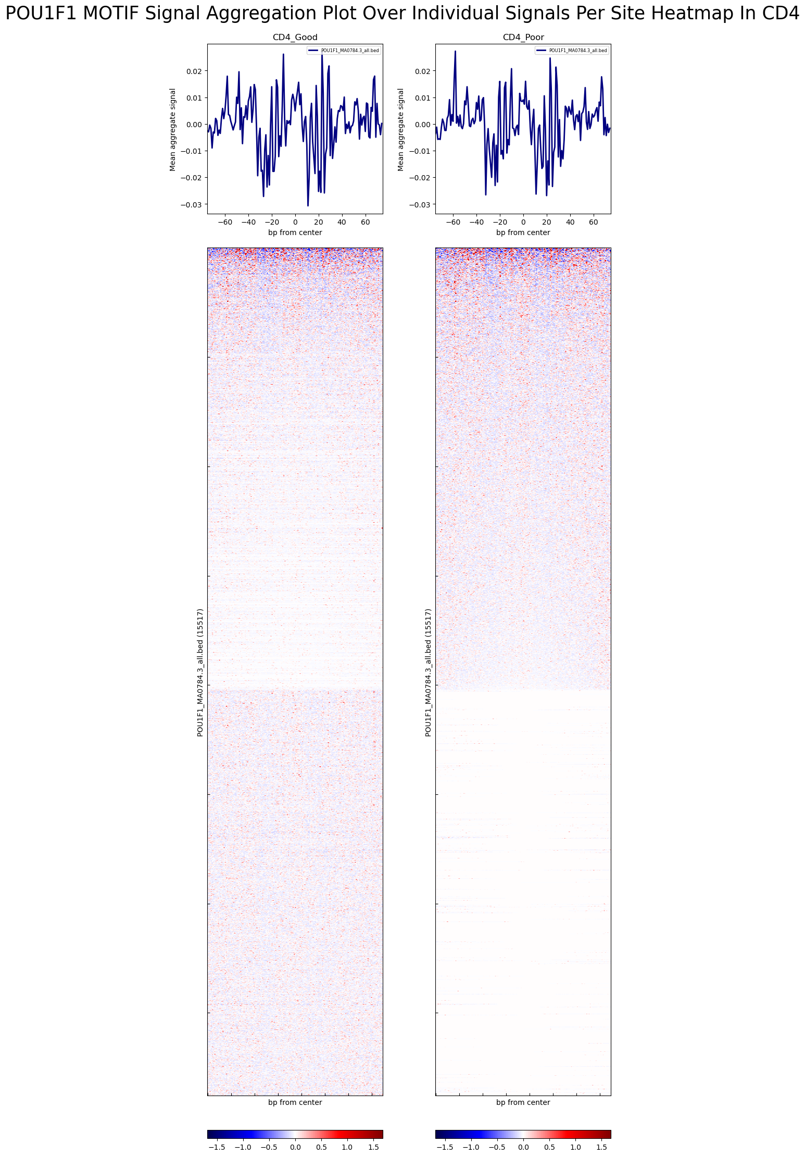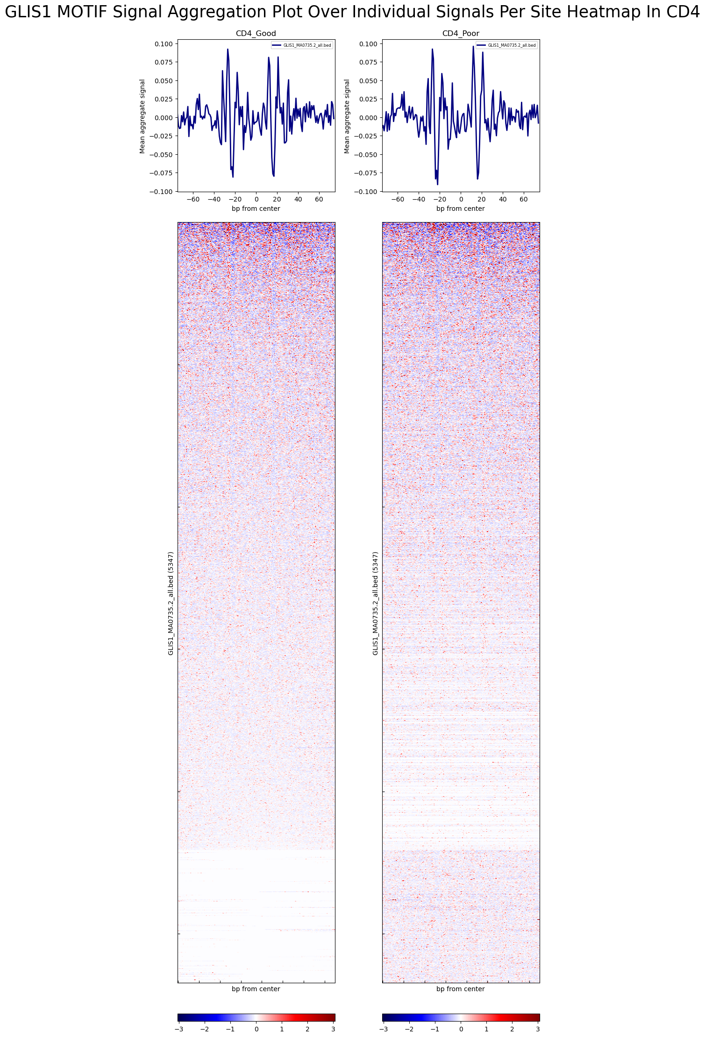

Figure Legend:

A – Volcano plot displaying differentially bounded motifs between good and poor CD4 groups. Significant genes p-value < 0.05 and |log2FoldChange| > log2(0.9) are highlighted in red. The x-axis represents log2 fold change, while the y-axis represents -log10(p-value). Key upregulated motifs are labeled.

B – Comparative footprint aggregate plots of chosen TFs (POU1F1, POU4F3, GLIS1 and VEZF1) binding in CD4_Good (left), CD4_Poor (middle), and their direct comparison (right). The x-axis represents base pairs from the center of the motif, and the y-axis shows the mean aggregate signal. The comparison panel overlays the corrected footprints of CD4_Good and CD4_Poor, highlighting differences between the groups. Dotted lines indicate the center of the motif.

C – Heatmaps and aggregate plots for chosen TFs (POU1F1 and GLIS1) binding across CD4_Good (left) and CD4_Poor (right) groups. The upper panels show the mean aggregate signal across the transcription factor motif sites. The lower panels depict heatmaps where the x-axis represents base pairs from the center of the motif and the y-axis represents individual binding sites ranked by binding intensity. The red and blue color scheme indicates the relative signal strength at each binding site, with red representing stronger signals and blue indicating weaker signals.

CD8 Good vs Poor

Differentially Bound Motifs Volcano Plot

**A**



Aggregated Footprinting Plots And Heatmaps

Aggregate Plots

**B**

**CD8_Up_Good:**

POU4F3 –

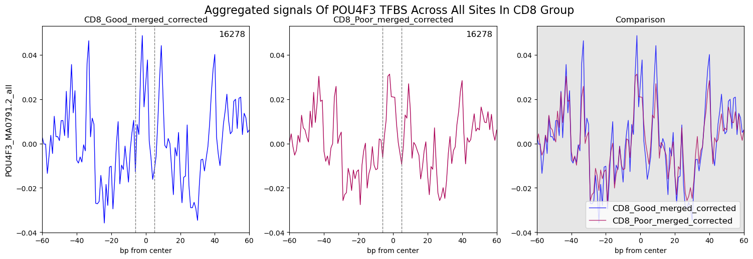

MOEX1 –

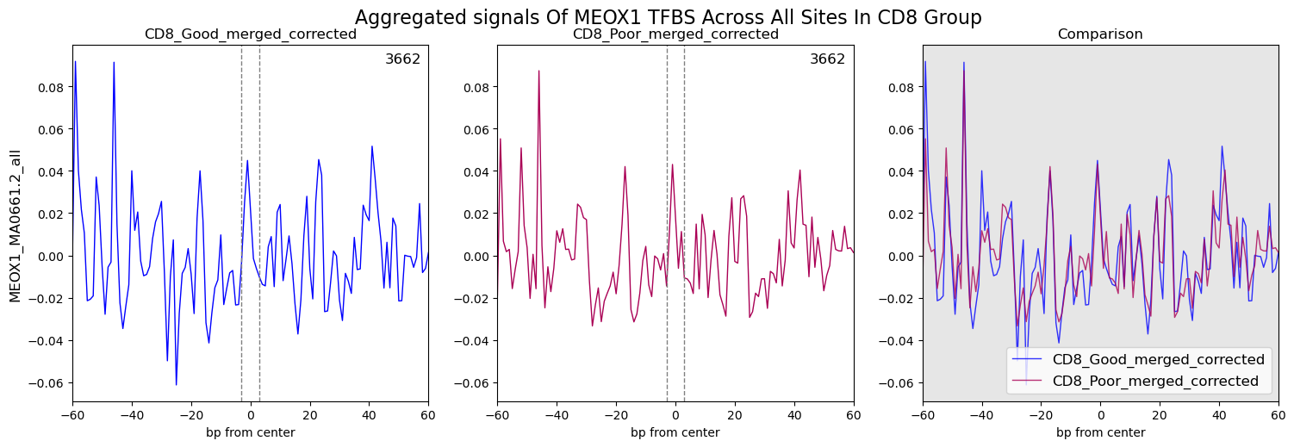

**CD8_Up_Poor:**

VEZF1 – 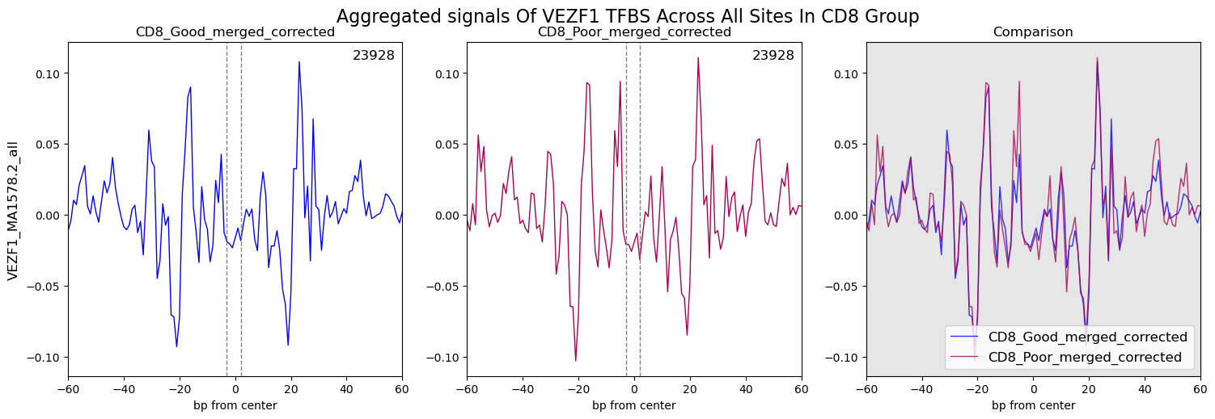

**CD8 Heatmaps**

**C**

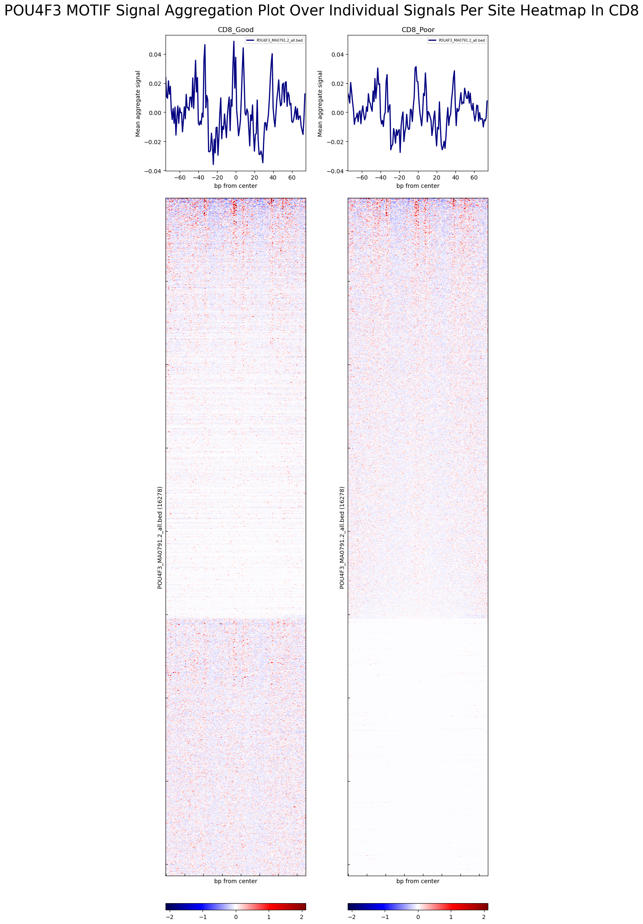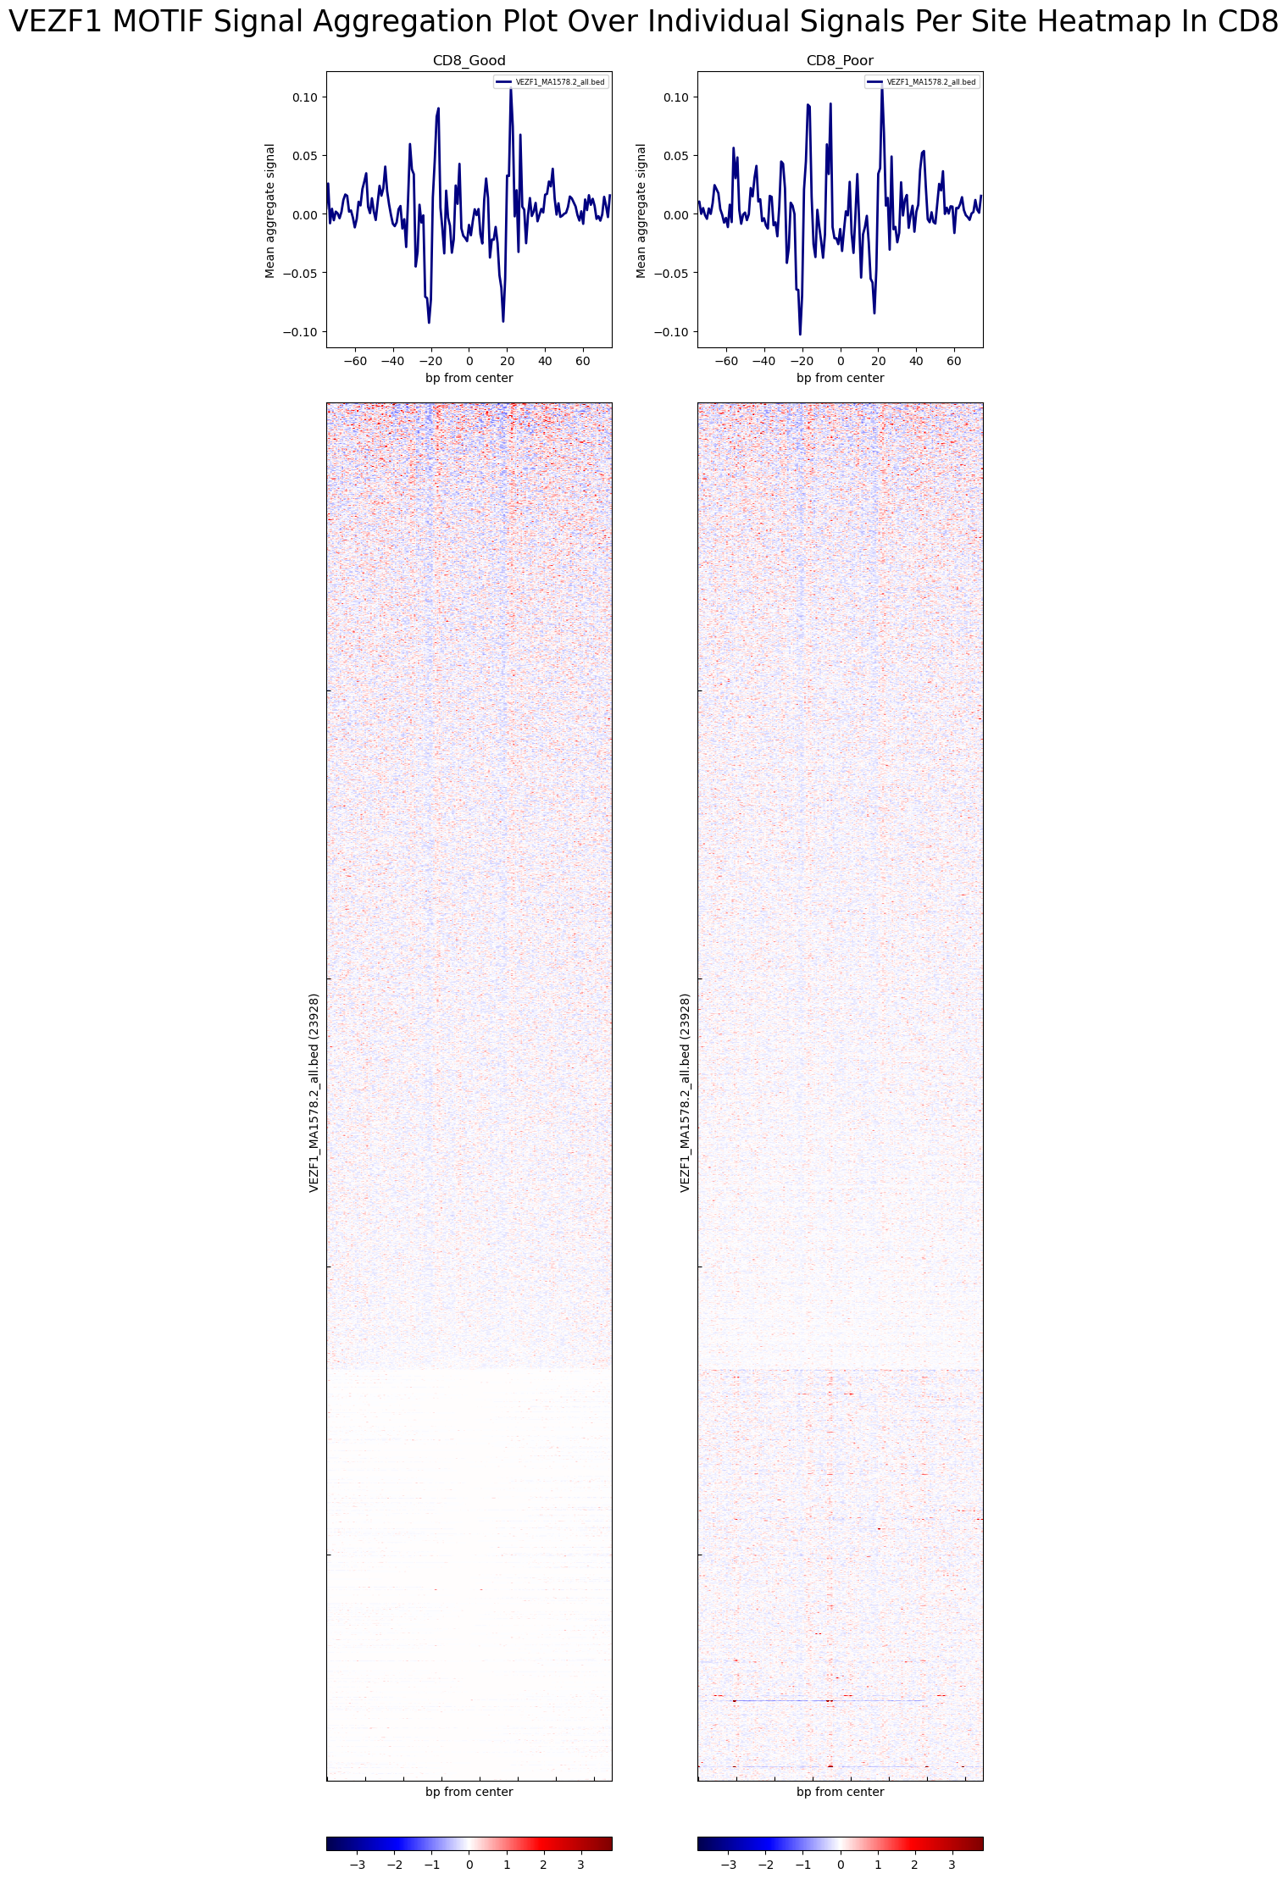

Figure Legend:

A – Volcano plot displaying differentially bounded motifs between good and poor CD8 groups. Significant genes p-value < 0.05 and |log2FoldChange| > log2(0.9) are highlighted in red. The x-axis represents log2 fold change, while the y-axis represents -log10(p-value). Key upregulated motifs are labeled.

B – Comparative footprint aggregate plots of chosen TFs (POU4F3, MOEX1 and VEZF1) binding in CD8_Good (left), CD8_Poor (middle), and their direct comparison (right). The x-axis represents base pairs from the center of the motif, and the y-axis shows the mean aggregate signal. The comparison panel overlays the corrected footprints of CD8_Good and CD8_Poor, highlighting differences between the groups. Dotted lines indicate the center of the motif.

C – Heatmaps and aggregate plots for chosen TFs (POU4F3 and VEZF1) binding across CD8_Good (left) and CD8_Poor (right) groups. The upper panels show the mean aggregate signal across the transcription factor motif sites. The lower panels depict heatmaps where the x-axis represents base pairs from the

**Summary**

**Open Chromatin Analysis:**

1. At a global scale, no significant differences were observed between poor and good responders in either CD8 or CD4 cells.
2. However, differential expression analysis identified significant sites in both CD4 and CD8 cells between the two groups.
3. Further investigation explored the enriched pathways through GSEA.

**Transcription Factor Binding Sites Analysis:**

1. Differentially functional transcription factors (with more bound sites) were identified in both poor and good responders across CD8 and CD4 cells.
2. The signal strength of differentially bound sites was more pronounced in CD8 cells compared to CD4 cells.

# References

1. Andrews, S. (2010). FastQC: A Quality Control Tool for High Throughput Sequence Data. [Online] Available at: http://www.bioinformatics.babraham.ac.uk/projects/fastqc/
2. Bolger, A. M., Lohse, M., & Usadel, B. (2014). Trimmomatic: a flexible trimmer for Illumina sequence data. Bioinformatics, 30(15), 2114-2120. doi:10.1093/bioinformatics/btu170
3. Bushnell, B. (2014). BBMap: A Fast, Accurate, Splice-Aware Aligner. [Online] Available at: https://sourceforge.net/projects/bbmap/
4. Li, H. (2013). Aligning sequence reads, clone sequences and assembly contigs with BWA-MEM. arXiv:1303.3997v2 [q-bio.GN]
5. Ramírez, F., Dündar, F., Diehl, S., Grüning, B. A., & Manke, T. (2014). deepTools: a flexible platform for exploring deep-sequencing data. Nucleic Acids Research, 42(W1), W187-W191. doi:10.1093/nar/gku365
6. Zhang, Y., Liu, T., Meyer, C. A., Eeckhoute, J., Johnson, D. S., Bernstein, B. E., ... & Liu, X. S. (2008). Model-based analysis of ChIP-Seq (MACS). Genome Biology, 9(9), R137. doi:10.1186/gb-2008-9-9-r137
7. Bentsen, M., Goymann, P., Schultheis, H., Klee, K., Petrova, A., Wiegandt, R., ... & Theis, F. J. (2020). ATAC-seq footprinting unravels kinetics of transcription factor binding during zygotic genome activation. Nature Communications, 11(1), 4267. doi:10.1038/s41467-020-18035-1
8. Rauluseviciute I, Riudavets-Puig R, Blanc-Mathieu R, Castro-Mondragon JA, Ferenc K, Kumar V, Lemma RB, Lucas J, Chèneby J, Baranasic D, Khan A, Fornes O, Gundersen S, Johansen M, Hovig E, Lenhard B, Sandelin A, Wasserman WW, Parcy F, Mathelier A **JASPAR 2024: 20th anniversary of the open-access database of transcription factor binding profiles** *Nucleic Acids Res.* in_press; doi: 10.1093/nar/gkad1059
9. Stark R and Brown G (2011). DiffBind: differential binding analysis of ChIP-Seq peak data. Bioconductor http://bioconductor.org/packages/release/bioc/vignettes/DiffBind/inst/doc/DiffBind.pdfRoss-Innes, C. S., Stark, R., Teschendorff, A. E., Holmes, K. A., Ali, H. R., Dunning, M. J.,Brown, G. D., Gojis, O., Ellis, I. O., Green, A. R., Ali, S., Chin, S.-F., Palmieri, C., Caldas, C., and Carroll, J. S. (2012). Differential oestrogen receptor binding is associated with clinical outcome in breast cancer. Nature 481, 389-393.
10. G. Korotkevich, V. Sukhov, A. Sergushichev. Fast gene set enrichment analysis. bioRxiv (2019), doi:10.1101/060012
11. Twelve years of SAMtools and BCFtools

Petr Danecek, James K Bonfield, Jennifer Liddle, John Marshall, Valeriu Ohan, Martin O Pollard, Andrew Whitwham, Thomas Keane, Shane A McCarthy, Robert M Davies, Heng Li

GigaScience, Volume 10, Issue 2, February 2021, giab008, https://doi.org/10.1093/gigascience/giab008